Notes from the Nurse
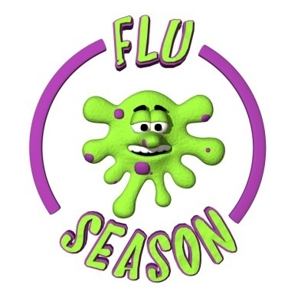

What to Know This Flu Season
It’s likely that flu viruses and the virus that causes COVID-19 will both spread this fall and winter. Here is what you should know this season, including information on how to protect yourself and your family against the flu.

Symptoms to Look For

Please do NOT send a child to school who exhibits two or more signs of COVID-19/ Flu including, but not limited to:
- Fever at 100.4 F or higher
- Cough
- Shortness of breath/difficulty breathing
- Sore throat
- Chills
- Muscle or body aches
- Headache
- New loss of taste/smell
- Diarrhea
- Nausea or Vomiting
- Nasal Congestion/Runny Nose

Verify/Update Your Emergency Contacts

If your child presents with COVID-or flu like symptoms while at school, he or she will be placed in an isolation room and will need to be picked up as soon as possible. Please make sure all phone numbers are current.

Wash Your Mask!

The Indiana State Department of Health recommends washing masks at least once per day. You can wash a mask by hand, or in a washing machine, just like you would wash laundry. Make sure the mask is allowed to dry completely before storing or wearing it. Please have an extra mask in your child’s book bag in the event the mask becomes dirty, lost, or your child forgets to bring one.

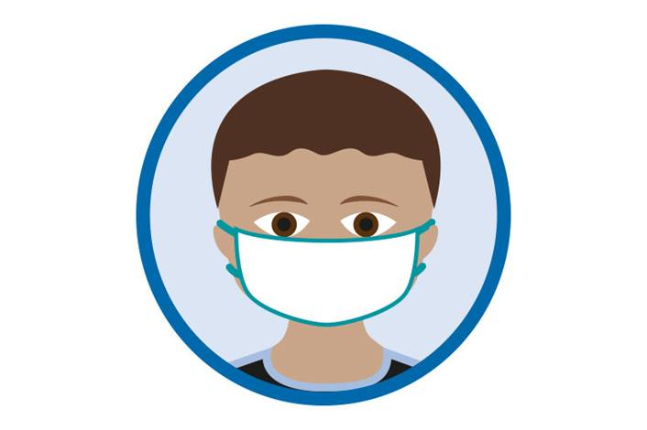
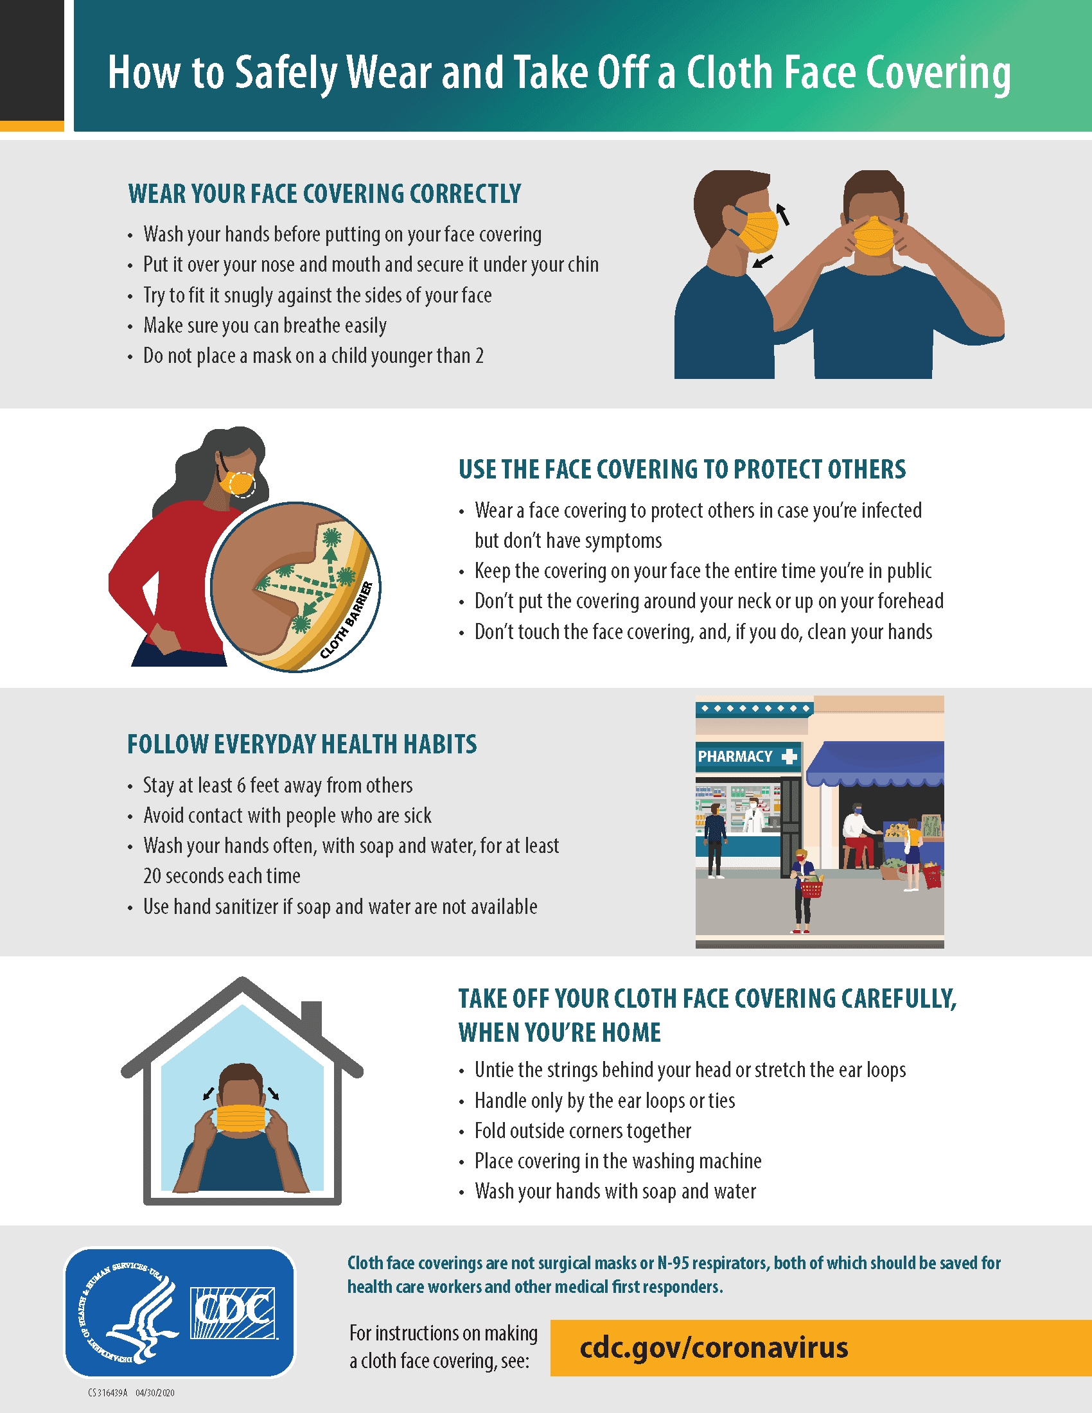


There are still families that have not turned in immunization records. Please turn in these forms at your earliest convenience so records can be updated.



Parents of 1st Graders: A few weeks ago, a survey was sent out via skyward and email to all 1st grade parents asking for permission to have your child’s vision screened by an eye doctor. If you have not submitted your answer to that survey, please do so as soon as possible! Thank you!

Change of Clothes

Kindergarten Parents: The weather is changing. Please have a change of clothes for the adequate season in your child’s backpack.

1st-4th Grade Parents: Please make sure your child is dressed for the weather when coming to school.

